New Taipei Art Village
Stationing Recruitment Plan
- Purpose
New Taipei Art Village (NTAV) is located in Tamsui, boasting its scenic mountains and the sea. It was a training center of the Taiwan Golf and Country Club, the first golf course in Taiwan. Near scenic spots, including Hobe Fort, Drop of Water Memorial Hall, Cloud Gate Dance Theatre, and Tamsui Golf Club, NTAV is the closest to nature among nearby scenic spots. NTAV is currently managed and operated by the New Taipei City Tamsui Historical Museum.
To encourage art and cultural creations, NTAV provides studio spaces for artists to develop their creativity and conceptions. Using the spaces as the bases, NTAV cultivates talent of the art, cultural, and creative industry, promotes exchange of artists of various domains, integrates abundant artistic and cultural resources in Tamsui, and builds a spatial platform for gathering humanistic and creative talent and facilitating their exchange.
- Environment
(1) NTAV and its surroundings
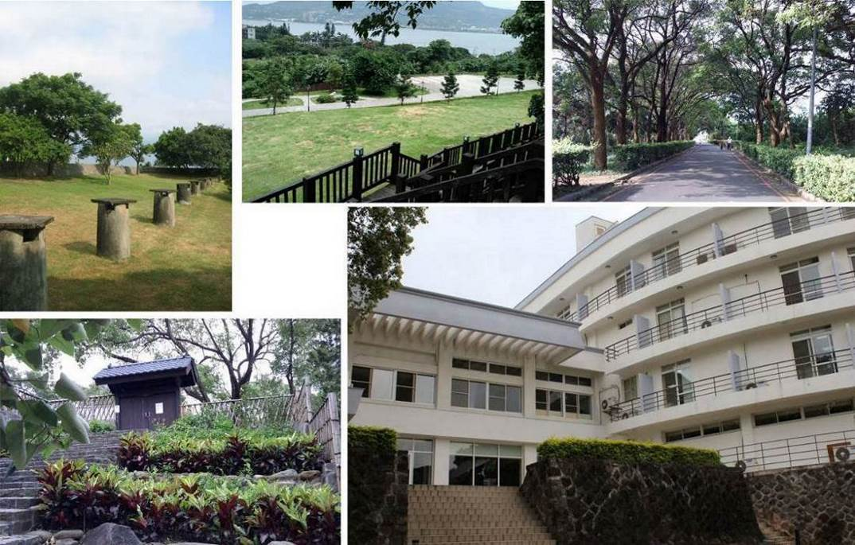
NTAV address: No. 32-2, Lane 6, Section 1, Zhongzheng Road, Tamsui District, New Taipei City

(2) Space for stationing
Floor | Area |  |  | Number of currently available rooms
3 | Small studio 29.8 m² |  |  | 4 rooms (301, 303, 304, 305)
4 | Small studio 29.8 m² |  |  | 3 rooms (403, 404, 405)
4 | Large studio 59.6 m² |  |  | 1 room (402)
A |  | B | C
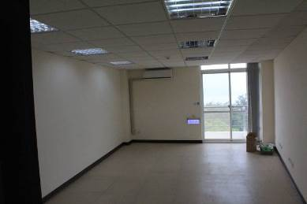 |  | 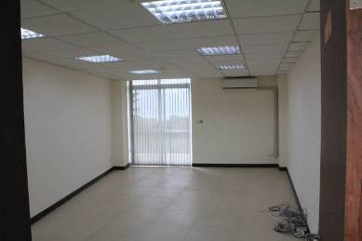 | 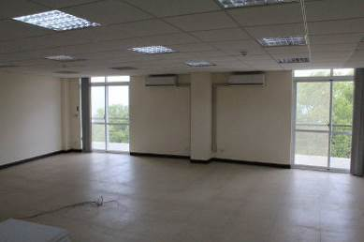
(3) Other public spaces
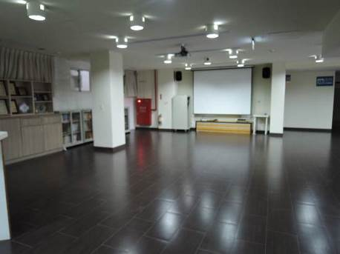 | 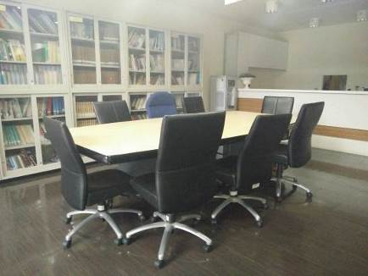
1F Art Exchange Hall 149.66 m² | 1F Conference Area of the Art Exchange Hall
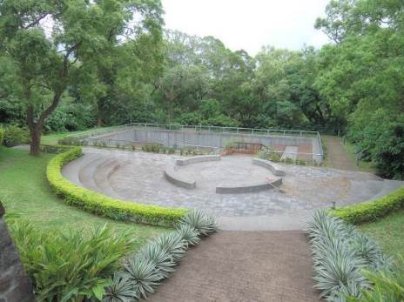 | 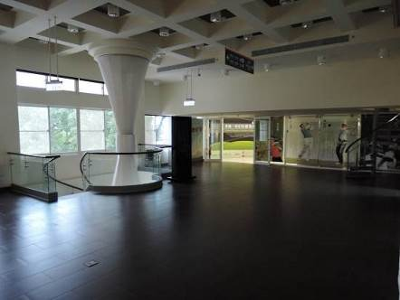
1F Outdoor theater | 2F Lobby
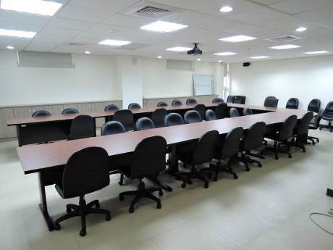 | 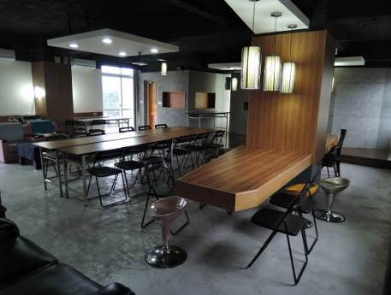
3F Multimedia conference room 72.79 m² | 4F Lounge 80.29 m²
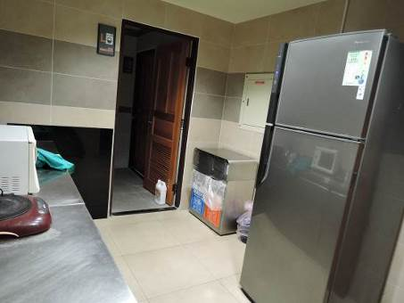 | 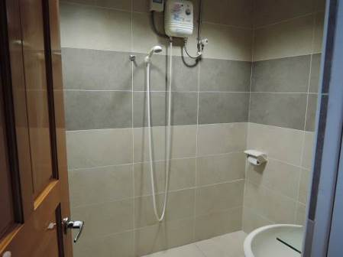
4F Pantry room (water dispenser, trash bin, and refrigerator) | 4F Bathroom
- Qualification
  - Independent art and cultural workers (or all members of a team) aged 20 years old or older of all nationalities can apply for stationing. The number of members in a team is not allowed to exceed four (Foreign individuals who can communicate in Chinese or English are preferred; they must also personally apply for their resident visa and extension).
  - Independent design, cultural and creative workers (or teams) aged 20 years old or older can apply for stationing. The number of members in a team is not allowed to exceed four (Foreign individuals who can negotiate in Chinese or English are preferred; they must also personally apply for their resident visa and extension).
- Application time and methods
  - Deadline: From the date of announcement to 17:00 o’clock on June 24 (Monday), 2019.
  - Submission: After the recruitment application documents (including the application form, stationing proposal, and portfolio of works for review) are completed as detailed in【Appendix 1】, the applicants send the forms through email under the subject “New Taipei Art Village—2019 Stationing Recruitment Application” to ai8704@ntpc.gov.tw.
(3) Other notifications
- Excessively large attachment or photograph files should be uploaded onto a network space or a cloud drive by the applicant. The applicant must also provide the relevant link or address in the application mail. The maximum file size is 300 MB.
- If the applicant does not receive reply mail from the New Taipei City Tamsui Historical Museum after submitting the required documents, the applicant is recommended to call the Museum to ensure if it has received the mail.
- Contact number: (02)2621-2830, ext. 214. Ms. Chen of the Exhibition and Education Group; contact at 9:00–12:00 and 13:30–17:30 from Monday to Friday.
- Review methods
  - Primary review: The Museum reviews all application documents (including the application form, stationing proposal, and portfolio of works for review). Those that do not conform to the requirements will be notified to supplement required documents within a limited period by the Museum. Applicants fail to supplement the required documents within the given period will be disqualified.
  - Secondary review: The review committee reviews stationing applications of applicants who satisfy the criteria of primary review. The applicant or representative is asked to brief the stationing project.
  - Review standards
- Completeness 40%  - Feedback plan 30%  - Relevance between the stationing project and local life in Tamsui 20% | - Team experience 5%  - Briefing 5%
- Result declaration
- On July 31 (Wednesday), 2019, the roster of selected artists will be declared with their priority order on News of the official website of the Tamsui Historical Museum. The selected artists or teams will be notified of the result individually.
- If the elected team station in NTAV for shorter than 1 year, teams on the reserve list will replace the teams that end stationing in a sequential manner. The replacing team will be notified when the result is declared.
- Stationing period
  - Within the period between September 1, 2019, and August 31, 2020, applicants must fill in expected duration of stationing in the application documents. The stationing period should be at least 6 months and 1 year at most.
  - During the stationing period, the stationing artists may stay overnight in NTAV; however, they must return NTAV before the curfew time stipulated by the Museum.
- Rights and obligations
  - The selected team must reply their stationing willingness within 5 days of receiving the notification and complete signing stationing contracts within a stipulated period. Those who fail to finish the required procedure within the period are no longer qualified; the space will then be given to artists on the reserve list in order. The disqualified applicants are not allowed to argue.
  - Equipment and resources:
      - Studio:
        - A studio key, an air-conditioning device, a network socket, a closet, and a shelf are provided in the room. Desk and chair sets can be provided with a maximum number of four sets depending on the number of applicants.
        - No other equipment or decoration is provided in the space. The stationing artists should decorate the space by themselves; however, they are not allowed to damage the structure safety or foul up the environment.
      - Public space:
        - 1F: Art Exchange Hall, Conference area, and outdoor theater; 2F: Lobby; 3F: Large conference room (with projective and broadcast systems); 4F: Lounge (with projective and broadcast systems); applicants must register for using the facilities with the Museum personnel responsible for stationing affairs.
        - 4F: Pantry room (including a water dispenser and a refrigerator) and bathroom. The stationing artists can use these facilities freely. Foods stored in the refrigerator must be labelled with the owners’ name. The Museum will assign cleaners to clean the refrigerator periodically.
      - Other needs related to work or stationing equipment (e.g., easel or hooks) should be proposed in the applicant documents. The Museum will provide necessary supplies as required during the stationing period.
  - The stationing art teams should share part of the water and electricity bill of NTAV (No. 32-2, Lane 6, Section 1, Zhongzheng Road, Tamsui District, New Taipei City; electricity bill customer number: 16-61-0108-13-6; water bill customer number: 1B-21-1331-16-2). Users stationing in large and small studio rooms should share 6% and 3% of the bills, respectively. The effective date begins from the day the stationing agreement is signed on.
  - Cooperative measures
      - During the stationing period, the stationing artists must attend the stationing outcome exhibition and activity held by the Museum. If the artists stationing in NTAV for shorter than a year cannot attend the outcome exhibition and activity, they must hold their own outcome presentation event.
      - Stationing teams comply with the NTAV Stationing Regulations (Appendix 2) and agreement (Appendix 4). Facilities and equipment must be checked before and after stationing. The equipment list is provided in Appendix 3.
      - The stationing teams cooperate with the marketing events arranged by the Museum; they shall receive filming of individual activity documentaries and interviews.
      - The stationing art and cultural creative teams in large and small studios shall respectively host at least 6 and 4 feedback plans every year, as listed below:
- The artists negotiate the host time with the Museum and hold dynamic art and cultural events such as art and cultural education, DIY events, speeches, performance, and workshops free of charge in NTAV, historical sites and business spots governed by the Museum, or junior high or elementary schools in Tamsui.
- The artists shall decorate the inner space of the studio rooms for celebrating festivals including the Chinese New Year, Lantern Festival, the International Museum Day, and Christmas. However, because the spaces of the Museum are mostly historical structures, painting, coloring, or renovation works are prohibited.
- The artists provide design, illustrations, and video-based cultural and creative industry plans free of charge for the Museum to market local culture. The artists’ works may also be used by the Museum for storage, exhibition, and other educational and promotional purposes.
- Stationing for shorter than 6 months is deemed as 6 months; the feedback sessions are thus halved. Artists in large and small studio rooms need to host three and two feedback events respectively.
      - Depending on the nature of the stationing team, the stationing workshop is available.
  - Other matters not covered in this document are negotiated by both parties.

【Appendix 1】
New Taipei Art Village
Stationing Recruitment Application Form
Number: (completed by the Museum)
Name of the team: (for individual applicants, the real name, alias, or any preferred name can be filled here)
Stationing period | From_______________(DD/MM/YYYY) to _______________ (DD/MM/YYYY)  (From September 1, 2019 to August 31, 2020; a minimum of 6 months to a maximum of 1 year of stationing the time should be filled in depending on applicants’ needs)
Desired studio room number in order of priority | 1. | 2. |  | 3. |  | 4. |  | 5.
Address of the representative
Email address of the representative
Phone number of the representative | (Cell phone, office phone, and home phone numbers should be provided as well as the preferred contact time to facilitate connection)
Photographs of the members  (Passport port photos of 2.9 cm× 3.9 cm or 3.7 cm × 4.8 cm sizes or personal photos or images cut from selfies that can reveal clear facial contour and features can be used. The representative’s photo should be attached to the leftmost cell.) | 
Name
ID card number
(Resident visa number for foreign applicants)
Birth date
(e.g.,19XX/XX/XX)
Contact number (cell phone recommended)
Emergency contact person
Relation
Phone number of the emergency contact person
Other needs | (e.g., easels, hooks, or any other equipment you need)
Applicants’ ID card or passport copies | Please attach the front and back copies of the ID cards (or resident visa or passports for foreign applicants) of all members. Scanning images or photographs uploaded through a computer are acceptable.
Applicants’ ID card or passport copies | (Front) |  |  |  | (Back)
Applicants’ ID card or passport copies | (Front) |  |  |  | (Back)
- After carefully reading the requirements of the application to Tamsui Historical Museum, I propose this application in accordance with regulations. If the application is approved, I will follow the relevant regulations as noted.
- I hereby declare that all information and attachments provided in the application documents and proposals are facts.

(Seals of the application unit and applicant)

【Team Name】Stationing Proposal
- Name of the project
- Principles
- Brief introduction to the applicant
- Team structure and principles
- Specialty
- Members’ education background and experience
- Recent outcomes
- Awards
- Content (including feedback plans)
- Items and content introduction of the project
- Space use and stationing plans
- Outcome presentation forms
- Feedback plans (holding art and cultural promotion events and feedback performances as listed in the recruitment brochure)
- Expected outcome and effectiveness

※At least 500 words of explanation, combined with photographs and illustrations
- Implementation time (September 2019 to August 2020)

(Space and stationing planning and contents of feedback plan implementation are to be provided in the form next page.)
6. Appendix (Registration certificate or proof of holding relevant art and cultural events, such as photographs)
※Not exceeding five A4 pages in principle

New Taipei Art Village Stationing Project Implementation Time Plan
Stationing period: Artist name:

Year | Month | Item | Practice
2019 | 9
2019 | 10
2019 | 11
2019 | 12
2020 | 1
2020 | 2
2020 | 3
2020 | 4
2020 | 5
2020 | 6
2020 | 7
2020 | 8
※ The size of form can be adjusted freely.

Portfolio of Works for Review
◎2D/3D works
Category |  | □______ type  □______ type | Attachment | A total of _______________ works
Number | Author name | Work title | Year of creation | Material | Size (H*W) | Picture of the work
1
2
3
4
5
6
7
8
9
10

◎Video/Dance
Work sequence | Author and work name | Year of presentation | Place of release | Brief explanation | Length  (minutes/ seconds)
1
2
3
4
◎Attachment
Downloadable link of the image, video, or audio files.
【Appendix 2】
New Taipei Art Village Stationing Regulations

- The security time of the Tamsui Historical Museum (hereafter referred to as the Museum) is 24 hours around the clock. The stationing team should comply with the curfew time of the Museum. No access time of the Museum is from 23:45 to 06:00. In case of any emergency (e.g., need of emergency medical services or laboring of a pregnant woman), the team must notify the Museum personnel immediately to open the entrance.
- For use of the Art Exchange Hall at the first floor, conference areas at the first and third floors, and the Lounge at the fourth floor for shorter than 4 hours, the applicants must issue the application to responsible personnel 3 days in advance. If the use duration is between 4 hours and 2 days, the applicants must issue the application 1 week in advance. For a long-term use over 2 days, the applicants must apply for using the areas 2 weeks in advance.
- If a stationing team intends to use the Lobby at the second floor to hold speeches or workshop events, they must apply to the responsible personnel a month in advance.
- When stationing teams use the public spaces, they must keep environmental cleanness and discipline from affecting others. The time from 12:30 to 13:30 from Monday to Friday is the lunch break of the Museum’s administrative personnel; stationing teams using the public spaces during this time period should lower their volume.
- The stationing teams can freely use the refrigerator at the fourth floor. Foods should be consumed before expiration. The cleaners of the Museum periodically clean the refrigerator biweekly. If the Museum needs to move stocks in the refrigerator because of the Museum event or cleaning requirement, the stationing teams should comply with the instructions of the Museum personnel.
- NTAV undergoes environmental disinfection of the public spaces once a month on a date to be announced. If the stationing teams encounter disinfection practices in NTAV, they should follow personnel’s instructions to leave NTAV or stay in their studio rooms to avoid inhalation of the disinfection chemicals that may compromise health.
- The stationing teams should maintain environmental cleanness of the studio room and remove their waste periodically. Trash, recyclable resources, and leftovers should be placed at the fixed spot at the fourth floor of NTAV. The teams should not bring garbage from outside and discard it in the Museum.
- NTAV is a non-smoking area. All stationing teams should refrain themselves from using devices with high electrical loads to avoid power failure.
The stationing team___________________ agreed on following the regulations as stated here in the New Taipei Art Village Stationing Regulations.
Representative:
【Appendix 3】 New Taipei Art Village
Studio room equipment and facility list
Stationing team name:
Stationing period:
Borrowed item | Date of borrowing | Signature of the borrower | Signature of the Museum personnel | Date of return | Signature of the borrower | Signature of the Museum personnel | Note
Key of the studio room
Number:
Air-conditioning remote control
Number:
Table
Number:
Folding chair Number:
Closet
Number:
Chair with cushion Number:
Shelf
Number:

【Appendix 4】
New Taipei International Art Village
Agreement for Artist-in-Residence Program Following Call for Cultural Creative Teams

Contracting Parties:
The Tamsui Historical Museum ( hereinafter called Party A)
_____________ ____________( hereinafter called Party B)
This agreement is made and entered into by and between the parties concerned to carry out the Artist-in-Residence Programs at the New Taipei International Art Village. The terms and conditions mutually agreed upon are as follows:

Article 1. Usage
This plan is meant to provide Party B with the Studio number_______ at the New Taipei International Art Village (Refer to Artist-in-Residence Program Agreement General Rules for the range of spaces). Party B shall use the space according to the stationing proposal which has been approved by Party A.

Article 2. Period of Use
From dd/mm/yyyy to dd/mm/yyyy.
Party B shall use the space in accordance with the stationing proposal applied for and the period of use shall not be extended unless permission is granted by Party A. Party B shall be given a key from the day of residency so as to go in and out the International Art Village freely. Party B may make duplicate keys to share with his/her/its other workers provided Party A permits so. The keys (including the duplicate ones) shall be kept carefully and returned to Party A before Party B checks out.

Article 3. Sharing of Water and Electricity bills
Party B shall share ______% of the water and electricity bill of New Taipei International Art Village (No. 32-2, Lane 6, Section 1, Zhongzheng Road, Tamsui District, New Taipei City; Electricity bill customer number: 16-61-0108-13-6; Water bill customer number: 1B-21-1331-16-2).

Article 4. The Usage and Maintenance of the Studio
I. Party B shall treat the studio with the care and duties of a good administrator. Shall Party B or if Party B allows a third party to intentionally or negligently cause the studio to be damaged or lost resulting in a loss of income, Party B shall be liable for damages. In the event the third party suffers prejudice, Party B shall be responsible for damages. In the event Party A suffers prejudice(including state liability), Party B shall be liable for damages.
II. Party B shall be responsible for the safety and use of the space while exercising the care of a good administrator and the environmental space shall be kept clean and tidy, the filters of the air conditioners are to be cleaned regularly and the safety of the facilities maintained, which shall be subject to the inspection of Party A and the competent authorities.
III. Party B shall treat with care all the tables, chairs, equipment and facilities borrowed from Party A while exercising the care of a good administrator. Shall any damage or loss be caused, Party B shall be responsible and compensate accordingly.

Article 5. When, as a result of natural disasters, unforeseen events or other force majeure reasons, Party B is unable to make use of the space as stipulated in Article 2, Party B shall immediately notify Party A. After Party A's verification and if found genuine, the Agreement shall be terminated. Party B shall return the space.

Article 6. Use of Space
I. Party B shall not use the space for any other purpose than that it is planned for and shall not lease, lend or let to others all or part of the space without the consent of Party A. In case of any breach, Party A shall terminate the Agreement and recover the space for use.
II. Party A can have usage or space adjustment needs, Party A shall be able to maintain the right to adjust space. Even after Party B has taken hold of the studio, Party A may still require Party B to move out of the original studio and transfer to other studios in the art village.
III. Use of open flame is forbidden in the art village. In order to be in line with the spirit of energy conservation, carbon reduction and ecological maintenance of the Museum, air conditioning shall be reduced. If climatic factors (like temperatures of 30℃ or more), air conditioning must be turned on but set at 26℃.
IV. Party B shall carry out garbage classification and maintain a clean environment. The kitchen waste shall be placed into the Kitchen Waste Bin.
V. Owing to the limited equipment and resources ( chairs, tables, projector equipment) in the art village, Party A shall discretionally consider providing Party B with internal resources and Party B shall return them to Party A after use.

Article 7. Party B shall not use this agreement as pledge or guarantee or for similar use

Article 8. Party B shall use the space in accordance with the residency plan. Party A shall check the usage of the room from time to time and make the inspection as a reference to other application plans made for the future.

Article 9. Termination and Compensation.
I. Party A shall have the right to terminate Party B’s usage of the space in the case of any one of the following circumstances and Party B may not ask for reparation or compensation from Party A:
(1). The government implements state policies or urban plans or, as a result of development needs, carries out public utility needs or exigencies of service or make changes in accordance with the law.
(2).Party B uses the space against the laws and regulations.
(3).Party B damages the space and other equipment and refuses to restore the damage caused.
(4). The studio is burnt due to the responsibility attributed to Party B’s misconduct.
(5). Party B carries out the construction, renovation or reconstruction without authorization.
(6). Party B violates any of the terms stipulated in this agreement.
(7). This agreement shall be terminated in accordance with certain laws and regulations.
II. Shall Party B make a breach of contract, he/she/it shall be responsible for the damages and compensation unless otherwise agreed upon. If Party B includes several persons, they shall be jointly and severally liable for damages.
III. Prior to Party B terminating the use of space, Party B shall ask Party A whether or not to deliver the space in accordance with the present situation. Unless otherwise stipulated in this agreement letter or if Party A consents it to be returned it in accordance with the present situation, Party B shall, then, return the space to Party A, in its original state.
IV. Party B shall return the space to Party A on the date the agreement shall be terminated or expires. In the event Party B has not taken out his/her/its remaining belongings within the time limit after Party A's notification, they shall be deemed to be abandoned. Party A will dispose of it and Party B shall be responsible for the clearance and processing expenses.
Article 10. Shall Party B intend to terminate the use of the space in advance, Party B shall submit a written application, to Party A, 15 days beforehand and the Agreement shall be terminated if Party A consents to it. Party B shall not ask Party A for any reparation or compensation.

Article 11. Party B shall guarantee that his/her/its creations and project application do not infringe upon the copyrights of others. Shall such a situation arise and results in the loss of Party A's reputation or in a claim of compensation from Party A, Party B shall be fully liable for all the damages caused and make the compensation accordingly.

Article 12. Cooperation Matters
I. During the period of residency, it shall be necessary to participate in the Artist-in-residence Outcome Exhibition and activities organized by Party A every year; for those residents who/which have been in the village for less than one year and are unable to participate in the Artist-in-residence Outcome Exhibition shall hold an outcome presentation instead.
II. Party B agrees to authorize Party A to disseminate publicly, report and display its activities for promotional and marketing purposes; the property rights of the video, audio recordings, photos and written records of the interviews shall belong to Party A.
III. During the period of residency of the art and cultural creative teams, the large studios shall host at least 6 Feedback Projects yearly and the small studios, 4 Feedback Projects yearly. For those teams with less than half-year residency, it will be considered as a half-unit, thus the number of Feedback Projects to be hosted shall be halved.

Article 13. Dispute Settlement.
I. Both parties shall abide by this agreement based on the principle of integrity. In the event of any litigation, the Taiwan New Taipei District Court shall be chosen as the jurisdiction court.
II. In the case a lawsuit is filed against Party B as a result of its breaching the Agreement, all the legal costs and attorney's fees shall be borne by Party B.

Article 14. In the event of any matter not covered in this Agreement arises, it shall be dealt in accordance with the principles of kindness, friendliness, fairness and reasonableness.

Article 15. The "New Taipei International Art Village Agreement for Artist-in-Residence Program Following Call for Cultural Creative Teams" and the documents provided by Party B following the approval of A shall form part of this Agreement.

Article 16. This agreement may be amended or supplemented upon the consent of both parties.

Article 17. This agreement is made in quadruplicate, two originals and two copies, and becomes effective upon the apposition of the signatures and seals of both the parties concerned. Both parties shall keep one copy of the original agreement and Party A shall keep the two duplicate copies.

Party A: Tamsui Historical Museum
Representative: Po, Li-Mei
Address: No. 32-2, Lane 6, Section 1, Zhongzheng Road, Tamsui District, New Taipei City
Telephone: 02-2621-2830

Party B (Signature of Representative):
Telephone Number:

This ___ th day of ______________, 20__

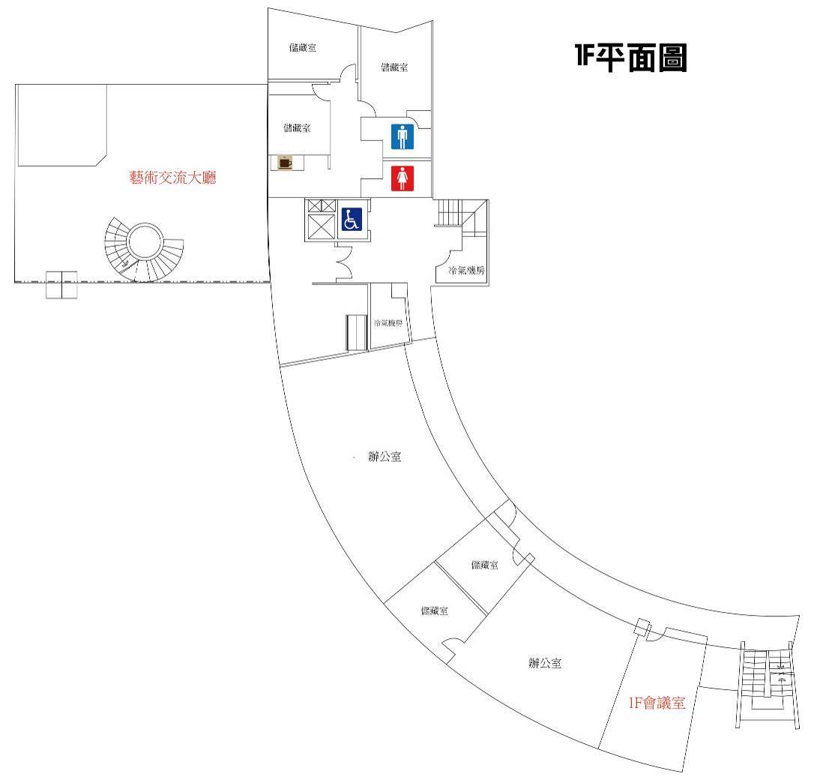
辦公室


